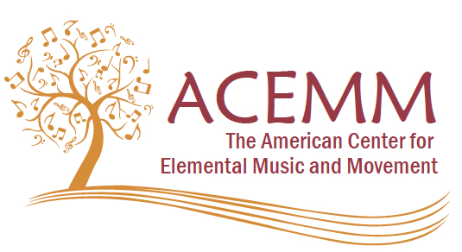

December 15, 2016

Dear Alexandra and Members of the Sierra Nevada Chapter AOSA,

We are pleased to inform you that one of your chapter members, David Thaxton has been chosen to receive the American Center for Elemental Music and Movement Spotlight Award, which recognizes outstanding music educators using an elemental approach in their teaching. He was nominated by a fellow music educator who admires the work he does with students and in his community. His profile will be published on the ACEMM website, [www.acemm.us](http://www.acemm.us), and will active for three months, beginning on January 3, 2017. We congratulate him!

The mission of the American Center for Elemental Music and Movement (ACEMM) is to promote the artistic and pedagogical possibilities of elemental music and movement. In the belief that all human beings have the capability and the need to express themselves through these media, the Center will offer educational programs and performance opportunities for children, youth and adults.

David’s work is very highly regarded and ACEMM is excited to honor him with the recognition he so deserves. I am sure you will want to let his fellow Chapter members know about this honor.

Sincerely,



Donna Fleetwood, Vice-President, ACEMM

On behalf of the Board of Trustees, ACEMM

Steven Calantropio

*President*

*Hamburg, NJ*

Donna Fleetwood

*Vice President*

*Dillwyn, VA*

Michelle Brady

*Treasurer*

*St. Louis, MD*

Drue Bullington

*Secretary*

*Lititz, PA*

BethAnn Hepburn

*Trustee*

*Southington, OH*

Brian Hunter

*Trustee*

*Hamilton, NJ*

Michelle Przybylowski

*Trustee*

*Huntingdon Valley, PA*

*Kristin Smith*

*Trustee*

*Gaithersburg, MD*

*1 Meadow Pond Road*

*Hamburg, NJ 07419*